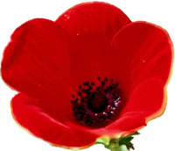REMEMBERANCE SUNDAY CHURCH PARADE

SUNDAY 9TH NOVEMBER 2008 at 10.30 am to 12 noon at The Haven Centre Church

IMPORTANT NOTICE

As part of the cub’s obligation to their Cub Scout promise we invite all cubs to attend the above service. In order to participate in the service the cubs will be representing the Royal Navy and we will give a short presentation to the congregation.

Please meet at the church at 10.20 am prompt. Cubs must be in full uniform please.

++++++++++++++++++++++++++++++++++++++++++++++++++++++++++

We apologise for the cancellation of cubs at the end of term at short notice. We ask that the cubs bring along their 60p item (as referred to in the newsletter for 22nd Oct.) and contribution for 12th November 2008.

Reminder – please can the cubs remember to bring their items for display at the art exhibition and (if they wish) cakes to sell on the evening of 19th November. We hope that all parents and brother/sisters will also join us (entrance fee 60p per family) to help the cubs raise enough money to buy a goat for Oxfam.

Akela

