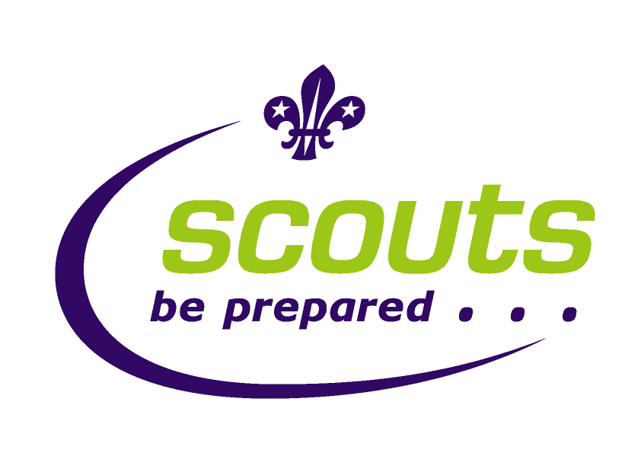
173rd Derby (Heatherton) Scout Group
Reg.Charity No: 46366

Order Form

We have a group polo shirt/T-shirt that is available to order. They are bottle green and have our distinctive logo on them. They are ideal to wear under uniforms for an extra layer in winter and for wearing in the warmer summer months.

They are a great way of feeling part of the group and allow us to identify our young people when out and about!

If you would like to order, then please complete this form and return it to your section leader with payment. Cheques can be made payable to: “173rd Derby Scout Group”.

Name of Beaver/Cub/Scout:

Section: Beaver/Cub/Scout (please delete as appropriate)

Your Name:

Contact ‘phone number:

Polo Shirts | Price per shirt | Number required | Cost
Age 7/8 | £7.40
Age 9/10 | £7.40
Age 11/12 | £7.40
Age 13 | £7.40
Adult small | £13.73 (inc. VAT)
Adult medium | £13.73 (inc. VAT)
Adult large | £13.73 (inc. VAT)

T-shirts | Price per shirt | Number required | Cost
Age 7/8 | £5.85
Age 9/10 | £5.85
Age 11/12 | £5.85
Age 13 | £5.85
Adult small | £7.82 (inc. VAT)
Adult medium | £7.82 (inc. VAT)
Adult large | £7.82 (inc. VAT)

Total money enclosed:

